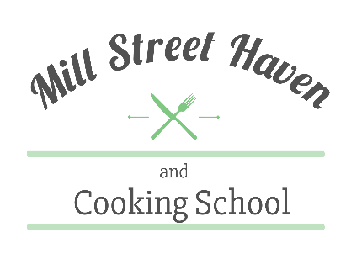

Here are some ideas for classes:
Wine and Cheese Pairings – How to create a perfect cheese board. Impress your friends with 3 tasty and delightful cheeses that you can pair together for your next gathering. Bring three of your favorite wines and I will design a beautiful cheese presentation along with appropriate accoutrements that will make a beautiful cheese course.
$25 per person - Max number 10 people
Appetizers for Holidays and all seasons – Let’s get this party started! This class will be seasonal in nature and will feature 3 mouth watering tasty treats to start off any meal. From cheeseballs, to hot and cold appetizers, Mill Street Cooking School will have some tempting appetizers in store for you!
$35 per person – Max of 8 people
Soup Class – If the weather is frightful, or the weather a beautiful, there is a soup for every season! Dive into this class with an open mind and tummy that is ready for soup. Depending on the season, get ready for some hearty soups and stews that will be a crowd pleaser. We will also introduce you to some delicious cold soup options!
$35 per person - Max of 8 people
Main Dish Class - MOM what’s for dinner? Add some new recipes to your repertoire with some new ideas towards dinner! We will make two dishes.
$40 per person Max of 8 people
Full Meal Classes – for those that are looking for a full meal, we suggest our full meal class. Depending on the season and what is fresh in the garden, this class will vary - you will be able to customize this class to your liking.
$55 per person Max of 8 people
Desserts - This class will include a variety of different desserts from coffee cakes or pies to cakes and even candy. We can discuss which sweet treats you are wanting to learn.
$35 per person Max of 8 people
Create Your Own Class – If you don’t want the clean up in your kitchen, use ours! We will customize a class based on your ideas and we will develop your own private cooking adventure!
Price Will Vary - Max of 8 people
Kids Class – We will make it fun and educational. From healthy snacks, to making dinner YOURself, to fancy cupcakes, you kids will have a blast!
$30 per person Max of 8 kids
Have an event you would like to discuss? Contact us! 480.239.3903 or Kathy@millstreethaven.com
